**ADR PROGRAM**

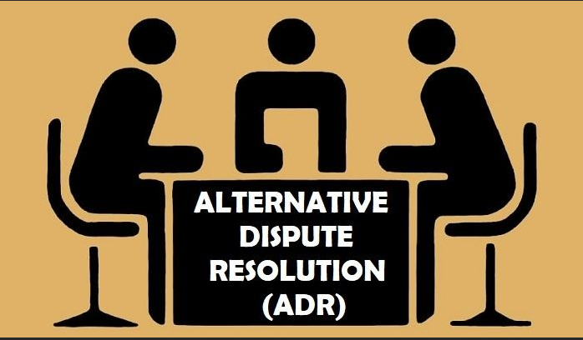

**What is Alternate Dispute Resolution (ADR)?**

ADR is a term used to describe a variety of approaches to resolving conflict

rather than traditional adjudicatory or adversarial methods. Examples of

traditional methods include litigation, hearings, administrative processes and

appeals.

**Core Principles**

The ADR program is built on fairness, which requires voluntary

participation, neutrality, confidentiality, and enforceability. All employees of the

Department of the Navy have the right to choose between ADR or EEO

counseling, where the agency agrees to offer ADR in a particular case, and

information about each procedure.

**Fairness**: Providing as much information about the ADR proceeding to the

parties as soon as possible; providing the right to be represented throughout the

ADR proceedings; and providing an opportunity to obtain legal or technical

assistance during the proceeding to any party who is not represented. Fairness

also requires the following elements:

* **Voluntary Participation:** Parties must knowingly and voluntarily enter

into an ADR proceeding. You do not give up any of your rights to

pursue the matter formally. You can end the Mediation or Conciliation

process at any time.

* **Neutrality:** ADR proceedings are impartial. A neutral third party will

be utilized. A “neutral” party is defined as an individual “who with

respect to an issue in controversy, functions specifically to aid the

parties in resolving the controversy.” This neutral third party may be

an employee of the Agency who can remain neutral regarding the

outcome of the proceeding or an employee of a different Agency.

* **Confidentiality** is essential to the success of all ADR proceedings.

When parties agree to participate in the ADR process a “Consent to

Participate in the ADR Process” form will be used to initiate the ADR

Process.

* **Evaluation:** An evaluation component is essential to any ADR

program and all parties are encouraged to fill out the

“ADR Evaluation” form. Your participation will assist in determining

whether the ADR program has achieved its core principles and will

provide feedback on how the program might be made more efficient

and achieve better results.

**ADR Techniques Used:**

***Mediation*** is the intervention into a dispute or negotiation of an acceptable,

impartial, and neutral third party who has no decision-making authority. The

objective of this intervention is to assist the parties in voluntarily reaching an

acceptable resolution of the issues in dispute.

***Conciliation*** is similar to mediation with the following exceptions: during

Conciliation, the Conciliator collects/reviews evidence and documentation,

provides counselling, develops factual information, and recommends options to

the parties for resolution. When requested by the parties, the Conciliator will

prepare an oral statement of the process including the strengths and weakness

of the dispute. The goal of conciliation is to reach a mutually agreeable and

appropriate resolution. The Conciliator is trained and skilled in matters related

to employment discrimination, including civilian personnel matters, and will

assist the parties in formulating a written agreement to resolve matters in the

dispute.

***Facilitation*** involves the use of techniques to improve the flow of information in

a meeting between parties to a dispute. The facilitator focuses more on the

process involved in resolving a matter. The facilitator meets with the parties as

a group and provides procedural direction as to how the group can move

efficiently through the problem-solving steps of the meeting and arrive at the

jointly agreed upon goal. Facilitators remain impartial to the topics or issues

under discussion.

***Peer Review (Not at all commands)*** is a problem solving process where an

employee takes a dispute to a group or panel of fellow employees and

managers for a decision. The decision may or may not be binding on the

employee and/or the employer, depending on the conditions of the particular

process.